 | THE CALVARY EXAMINER Reading Plan and Quiz | Issue # 87
In chapter 21:4-5 God said he would send his sword to go forth against all flesh. What was his purpose in doing this? V5 That all flesh may know that I the Lord have drawn forth my sword out of his sheath  To describe the imminent destruction of Israel, God used the analogy that the sword was ______ and ______? 21:11 sharpened, and it is furbished  What would be fuel for the fire of God’s wrath? 21:32 Israel, but particularly the Ammonites  What 7 things are mentioned as the sin of Israel in 22:11-12? - abomination with Neighbor’s wife - defiled his daughter in law - humbled his sister - taken gifts to shed blood - taken usury and increase - greedily gained of thy neighbors by extortion - hast forgotten me  Much is said in Ezekiel about the corrupt Prophets. What did these false preachers take in 22:25? taken the treasure and precious things;  What did God seek in 22:30? for a man among them,  Who else would face the wrath of God? 25:2 the Ammonites  What happened to people of the Ammonites? There is a reason we don’t hear about them existing as a nation in our day. 25:10 Unto the men of the east with the Ammonites, and will give them in possession, that the Ammonites may not be remembered among the nations.  The Philistines dealt by what? God said he would destroy them for their hatred. 25:15 the Philistines have dealt by revenge  When judgement would fall on the Philistines, God said he would cut off the Cherethims. What were the Cherethims? 25:16 "executioners"  Luke Last Week’s Answers – Issue # 86 | 10/20/24  THIS WEEK’S READING – Ezekiel 26-30  “THE PROPHECY OF TYRE”  By Pastor Doug Swafford  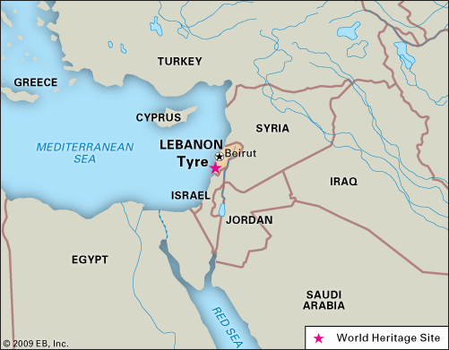  “And I will make thee like the top of a rock: thou shalt be a place to spread nets upon; thou shalt be built no more: for I the Lord have spoken it, saith the Lord God. ~ Ezekiel 26:14  _____________________________________  One of the most intriguing prophecies of the Old Testament has to do with the ancient city of Tyre. It was located in Phoenicia on the coast of the Mediterranean Sea. Tyre was about 100 miles north of Jerusalem. it was a wicked city announced by the prophets, and Ezekiel had an especially intriguing prophecy concerning its judgment.  First, we see the prophecy of its FLATNESS. I will make the like the top of a rock. The great city of Tyre was to be made flat like the top of a rock. This occurred when Alexander the Great invaded the land and scraped the ruins of the city to make a Causeway to an island about a half mile away.  There is also a prophecy here about FISHERMEN. Thou shalt be a place to spread nets. History tells us that the ruins of the city made good places for fishermen to lay their nets to dry. The greatness of the devastation of the city was emphasized by this prophecy.  Also, we see that it will be FINISHED. Thou shalt be built no more. One of the judgments predicted by God against Tyre was that it would be no more. Around 1300 AD whatever was left of the city and all its surrounding inhabitants was deserted and conquered by a Sultan of Egypt.  In His time and plan, God fulfilled the prophecies of this verse.

This Week’s Questions – Issue # 87 – Ezekiel 26-30

Why did God say, “Behold I am against thee O Tyrus?” 26:2-3
Who would God use to destroy Tyre? (Tyrus) 26:7

Tyrus was a great city. Chapter 27 speaks about how great the city was. What did God say the people would do when it was destroyed? 27:36

I believe that chapter 28:12-15 is speaking about Tyrus, but there is an illustration or type used for someone else? A great Cherub who was in Heaven and the Garden of Eden. Your thoughts?

No wrong answer.

The next prophecy in Ezekiel is in chapter 29. Who was Ezekiel to prophecy against next? 29:2

How long would Egypt not be inhabited? 29:11

Who would God give the land of Egypt to?

29:19

What 2 things did God say he would remove from Egypt? 30:13

What would happen to the inhabitants of Egypt? 30:23

At least twice in chapter 30 God says he is bringing judgement on Egypt. What was His purpose? 30:19 & 26

_____________________________________________________________________________
YOUR NAME

