 | THE CALVARY EXAMINER Reading Plan and Quiz | Issue # 178
Last Issue’s Answers  Ephesians 1-6 | 10/11/26  THIS WEEK’S READING – HOSEA 1-7  “NO TRUTH”  By Pastor Doug Swafford  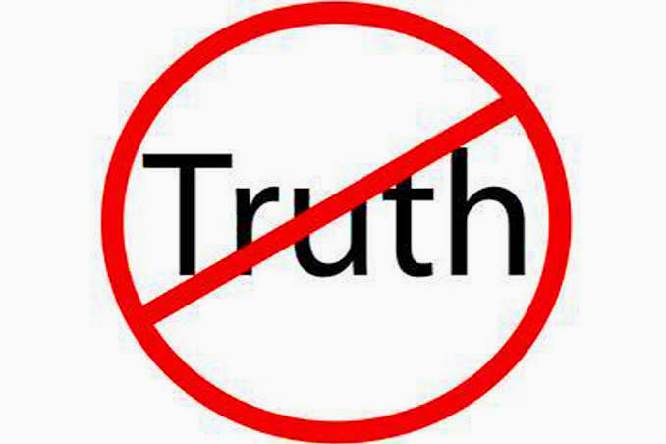  “Hear the word of the Lord, ye children of Israel: for the Lord hath a controversy with the inhabitants of the land, because there is no truth, nor mercy, nor knowledge of God in the land.” ~ Hosea 4:1  ____________________________________  The condition of the society in Hosea’s day describes the condition of our society. It is the condition that will bring the judgment of God.  Lack of truth. “There is no truth.” This lack of truth represents a lack of character in the land. The next verse details some of the evil in that day. “By swearing, and lying, and killing, and stealing, and committing adultery, they break out, and blood toucheth blood.” ~ Hosea 4:2. This sounds exactly like our day with crime and immorality.  Lack of mercy. “Nor mercy”. When we consider the cruelties of abortion, drunkenness, murders, and an overall lack of love, we perceive the lack of mercy and compassion in our land. If our government had any mercy it would go after these evils with vengeance, but it is evident that our government (who represent the people) have little mercy.  Lack of knowledge. “Nor knowledge of God.” The third sin in Hosea’s day was a lack of the knowledge of God. People do not know God and are ignorant of his will. Bibles are not read and churches are not attended. Spiritual ignorance abounds in our land and it's the worst ignorance of all. They can split the atom and send someone to space, but without the knowledge of God, there they have done nothing!
  What did God predestinate us unto? 1:5 | Unto the adoption of children by Jesus Christ to himself
  How do we have redemption? 1:7 | Through his blood
  How were we sealed after our redemption? 1:13 | With that Holy Spirit of promise,
  What condition were we in before we were quickened? 2:1 | Spiritually Dead
  What will happen in the ages to come? 2:7 | God will show us the exceeding riches of his grace in his kindness toward us through Christ Jesus.
  How are we saved? 2:8-9 | By grace through faith. Not of works
  What passeth our knowledge? 3:19 | The love of Christ
  What are we to endeavor to do? 4:3 | Unity with one another
  What did God give us for the perfecting of the saints? 4:12 | Apostles; and some, prophets; and some, evangelists; and some, pastors and teachers;  Apostles and prophets are two gifts that are no longer given. Once the Word of God was completed, these were no longer needed.
  Why should we redeem our time? 5:16 | Because the days are evil
This Week’s Questions – Issue # 178 – HOSEA 1-7

What did the people commit in the eyes of the Lord? 1:2

Why did God tell Hosea to name of the first child “Jezreel?” 1:4

Why did God tell Hosea to name the second child “Loruhamah?” 1:6

Why did God tell Hosea to name the third child “Loammi?” 1:9

Why did the harlot go after her lovers? 2:5

What would Israel be without “many days?” Six things are mentioned. 3:4

What would happen after Israel went without the things mentioned in verse 4? 3:5

What three things did Israel not have in the land? 4:1

What were some of the things that were being committed in the land? 4:2

What did God say he would do unto Ephraim? 5:14-15

__________________________________________________________________
YOUR NAME

