Issue # 60 |  | THE CALVARY EXAMINER | 03/24/24
Pastor Doug Swafford |  | Reading Plan and Quiz
“RIGHTEOUSNESS THROUGH THE HOLY SPIRIT”  One outstanding Bible scholar of the past made this statement, “If the Word of God was a ring, and the Epistle of Romans, was the precious stone within the ring, then chapter 8 would be the sparkling point of the jewel”  Most believers would agree that Romans chapter 8 is one of the most precious and beloved chapters in the entire Word of God. In chapter 8 we find the climax to the argument that began in chapter 3:21, that gospel righteousness through faith is in the finished work of the Lord Jesus Christ.  In chapter 3, we learn that righteousness is by faith.  In chapter 4, we are taught that the gospel righteousness by faith does not contradict Old Testament Scriptures.  Chapter 5 teaches us that by gospel righteousness obtained through the finished work of the Lord Jesus Christ, we are kept by the power of God. |  | 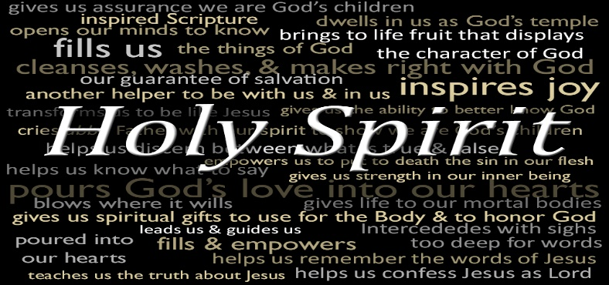  “There is therefore now no condemnation to them which are in Christ Jesus, who walk not after the flesh, but after the Spirit.” ~ Romans 8:1  _____________________________________  Chapter 6 shows us that sinful living is neither produced nor encouraged by the Gospel teaching of salvation by grace through faith, but that we are dead to sin and alive unto God through our Lord Jesus Christ. I’m glad the born-again believer can trust in Jesus to keep him instead of depending upon his own ability, which can never provide victory over the old nature. Divine nature brings victory to the believer.  Chapter 7 teaches that the believer sanctification by the law is utterly impossible.  Now in chapter 8 we learn that through the Holy Spirit, (who dwells in every believer) we can live a godly life, but only as we allow the Holy Spirit to lead us day by day. It is a wonderful thing for the believer to walk not after the flesh, but after the Spirit. He provides life and power, and we can know that condemnation has been removed!  Praise God for the work of the Holy Spirit in our lives!

THIS WEEK’S READING – ROMANS 6-10

THIS WEEK’S READING AND QUIZ – ROMANS 6-10

Last Week’s Answers – Issue # 59 This Week’s Questions – Issue # 60

Expound on Romans 6:1 in your own thoughts.
What should we never allow to reign in our mortal body? 6:11

Since we are now under grace, shall we sin? 6:15

We yield and obey to one of two things? What are they? 6:16

A person who is delivered from sin is now a servant to what? 6:18-20

What is the wages of sin? 6:23

How do have the gift of eternal life? 6:23

When is there no condemnation to them which are in Christ Jesus? 8:1

How many things are working together for the good - to those who love God? 8:28

What is one way we know that we are no longer under condemnation? 8:34
Who was made of the seed of David according to the flesh? 1:3 | Jesus Christ our Lord
What declared the Jesus Christ is the Son of God? | The spirit of holiness, by the resurrection from the dead:
What was spoken of throughout the whole world? 1:8 | The faith of the Believing Romans
What was Paul not ashamed of? 1:16 | …of the gospel of Christ

What are your thoughts regarding 2:11?
Who are under sin? 3:9-10. 3:23 | Both Jew and Gentile – “Everyone”
How do we have righteousness imputed unto us? 4:3-6 | …him that worketh not, but believeth on him (Jesus Christ)
Who staggered not at the promise of God? 4:20 | Abraham
What do we have because of faith? 5:1 | …we have peace with God through our Lord Jesus Christ:
How did sin enter into the world and what was the result? 5:12 | …as by one man (Adam) sin entered into the world, and death by sin; and so death passed upon all men,

_____________________________________________________________________________
YOUR NAME

