 | THE CALVARY EXAMINER Reading Plan and Quiz | Issue # 133
Last Issue’s Answers - Issue # 132 | 10/05/25  THIS WEEK’S READING – REVELATION 6-10  “PERSECUTION”  By Pastor Doug Swafford  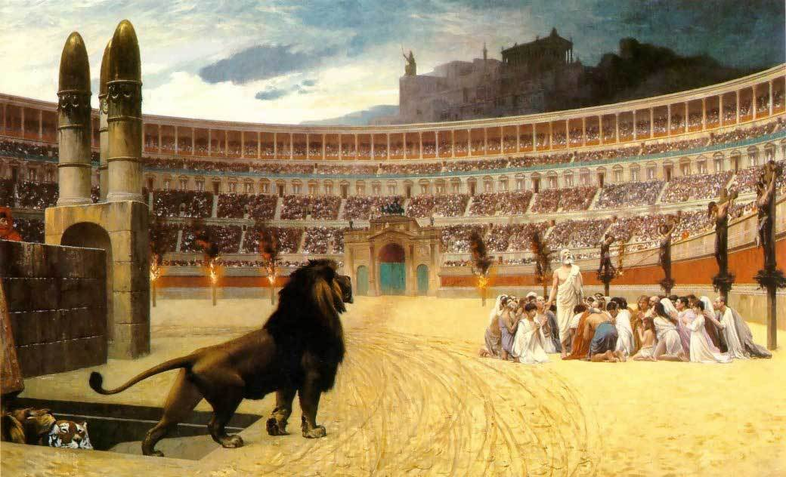  “And when he had opened the fifth seal, I saw under the altar the souls of them that were slain for the word of God, and for the testimony which they held.” ~ Revelation 6:9  ____________________________________  The apostle John is being given a revelation of future events in the Book of Revelation. Here he is given a view of the persecuted Saints.  Cruelty Of Persecution. “Souls of them that were slain.” Persecution is cruel and sometimes it kills. Persecution disguises itself at the beginning, but sooner or later it becomes bloody. Much persecution has happened in the past and some continues today around the world. The principles of our Lord Jesus Christ is hated by the world. Some of the persecution is simply legal restrictions, and some persecution calls for death.  Cause Of Persecution. “For the Word of God.” Those who persecute, hate the Word of God. Many call themselves Christians, but most of them do not truly believe in The Word of God, they despise it. Both the written Word (The Scriptures) and the Incarnate word (The Savior) are hated. If you honor the Word of God, and exalt Jesus Christ, sooner or later you will be the target of evil.  Consistence Of The Persecuted. “For the testimony which they held.” We notice the word, “held.” The persecuted will be slain because they are faithful, they “held” to the Word of God. You can get out of persecution if you stop holding faithful to the testimony of Christ. A true born-again Christian will hold true. Keep teaching, preaching, and living out the Word of God. Keep exalting Jesus Christ in everything you do. The souls who are under the altar are there because they were faithful, not flashy or fearful.
  The book of Revelation is a revelation about who?  1:1 | The Revelation of Jesus Christ
  Who bare the record of Revelation? 1:2 | The Apostle John
  What was the Revelation addressed to? 1:4 | The 7 churches in Asia
  Who spoke to John and gave him The Revelation? 1:10-11 | Alpha and Omega. The Lord Jesus Christ
  Which church was told they would be cast into prison? 2:8-10 | The Church in Smyrna
  Who had a Jezebel in the church? 2:20 | The Church in Thyatira
  Which church had things that were dying, and only had a few who had not defiled their garments and walked worthy? 3:2-4 | The Church in Sardis
  Which church was Lukewarm? 3:14-16  It’s a warning and an illustration of our church age. | The Church of the Laodiceans
  Where was John’s spirit taken after the churches were addressed? 4:1-2 | To Heaven (The Throne of God)
  Why did John weep? 5:4 | Because no man was found worthy to open or read the seven-sealed book,
This Week’s Questions – Issue # 133 – REVELATION 6-10

What is the name of the rider on the pale horse? What will he have the power to do? 6:8
Who will cry with a loud voice asking the Lord to avenge their blood?” 6:9-10

What will people say to the mountains and rocks at this time? 6:16-17.

What will four angels do in 7:1?

How many will be sealed from the 12 tribes of Israel? 7:4-8

Revelation 7:9-12 speaks about those who are clothed in white robes. Who are these people? 7:13-14

After the 7th seal is opened, how long will there be silence in heaven?

This represents to horror of the 7th seal

What is the name of the star that will fall and cause the waters to made bitter?

8:10-11

What will happen when the 4th Angel sounds his trumpet? 8:12

What will come out of the pit and torment men for 5 months. 9:1-12

A time so horrible that men will want to die, but they will not be able to die.

_____________________________________________________________________________
YOUR NAME

