 | THE CALVARY EXAMINER Reading Plan and Quiz | Issue # 91
The Bible describes the voice of God in what way in 43:2? This same illustration is used many times throughout Scripture. like a noise of many waters  During the sacrifice for sin, they were to take the blood of the bullock and place it where? 43:20 On the four horns. four corners. And border of the Altar  Who was to perform the burnt offering sacrifice in Ezekiel 44:10? Even though they went away from God The Levites  What were the priest to teach the people? 44:23 The difference between the holy and profane  What were the princes in Israel doing to the people prior to God’s judgement? 45:8-9 Oppressing, filled with violence and spoil  Who was to boil the sacrifices of the people? 46:24 the ministers of the house  How was the land divided? 47:21 according to the tribes of Israel.  The word “oblation” is mentioned about 35 times in the Scriptures. 48:9 is an example. What does the word “oblation” mean? Offering  Which group of people did not go astray when the children of Israel went did wrong? 48:11 – (Also mentioned in the devotional) The Sons of Zadok  What is the name of the city? I believe much of the latter part of Ezekiel refers to the Millennial Reign and Temple.48:35 The Lord is there.  Luke Last Week’s Answers – Issue # 90 | 11/17/24  THIS WEEK’S READING – ACTS 1-5  “OBSERVATIONS OF THE LOST”  By Pastor Doug Swafford  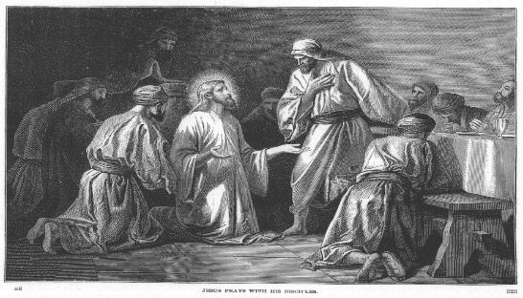  “Now when they saw the boldness of Peter and John, and perceived that they were unlearned and ignorant men, they marvelled; and they took knowledge of them, that they had been with Jesus.” ~ Acts 4:13  ____________________________________  Peter and John were on trial before the Sanhedrin because they had been preaching Christ. While the disciples were on trial, the Sanhedrin made some observations about the disciples that we read in this verse.  Men of Courage. They saw the boldness of Peter and John. These two disciples would not cowards before the Sanhedrin. This really bothered these leaders. Intimidation was one of the most effective methods for controlling the people. This is often the way evil men work but it did not work with Peter and John. The greatest courage is always displayed when men stand for Jesus Christ. Living for Jesus is not easy sometimes, rather it takes great boldness to live a consistent life for Christ.  Common Men. Perceived that they were unlearned and ignorant men. These words unlearned and ignorant do not mean that Peter and John were dummies, but it means they were not educated in the recognized religious schools of the Jews. They were considered just common. Peter and John had demonstrated considerable skill and knowledge before the Sanhedrin, and this bothered the Sanhedrin. It showed them up they did not like the followers of Christ to show wisdom in religious affairs.  As Christians we need courage as simple common people, to know what the Bibles says and tell it to others.

This Week’s Questions – Issue # 91 – Acts 1-5

Where were the people to receive their power to be a witness? Acts 1:8
Who preached on the day of Pentecost? 1:15

Who purchased a field, and he fell causing his bowels to gush out? 1:16-19

What was the name of the field? 1:19

Who were the two disciples that were appointed in 1:23? Only one was chosen. v26

What was the miracle of the tongues on the day of Pentecost? 2:6

Why were the priest and Sadducees grieved? 4:1-2

Who is the head cornerstone? 4:10-11

Who were the husband and wife that were killed because of their deceit? 5:1-10

What were the two men’s names who were false teachers? 5:36-37

They both drew away much people

_____________________________________________________________________________
YOUR NAME

