 | THE CALVARY EXAMINER Reading Plan and Quiz | Issue # 62
Last Week’s Answers – Issue # 61 | 04/14/24  THIS WEEK’S READING – 1 Corinthians 1-5
What tribe was Paul from? 11:1 BENJAMIN  What passage in the Old Testament is Romans 11:2-4 referring to? Book and Chapter 1 KINGS 19:14  Romans 12:2 is a great verse to memorize “And be not conformed to this world: but be ye _______________ by the renewing of your mind,” “Transformed”  In your own thoughts, please provide a real-life scenario/example of what 12:15 is referring to.  Who does vengeance belong to? 12:19 “The Lord”  What Old Testament passage is 14:11 referring to? Chapter and verse. Isaiah 45:23  Who was a servant of the church at Cenchrea? (a harbor town in Corinth) 16:1 “Phebe”  Which commandment do all others hinge on? 13:9 Jesus also repeated this in the Gospels. “Thou shalt love thy neighbour as thyself.”  What should we be continuing and instant in? 12:12 “instant in prayer”  As much as lieth in us – (With everything we have inside of us) What should we do if it is possible? 12:18 “live peaceably with all men.” | “THE METROPOLIS OF SIN”  Pastor Doug Swafford  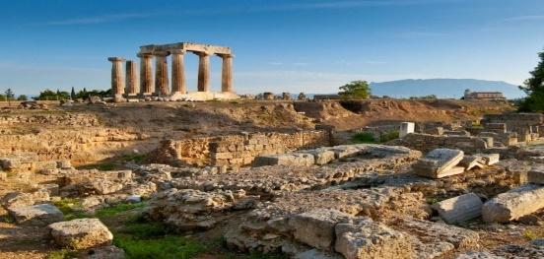  “And I, brethren, could not speak unto you as unto spiritual, but as unto carnal, even as unto babes in Christ.” ~ 1 Corinthians 3:11  _____________________________________  Corinth was a large city perfectly situated for commercial purposes. And through its great commerce, she became a very wealthy city. Thousands of traders from all known nations visited there as the Greek civilization flourished. Fine Arts were cultivated, athletic games and schools of philosophy flourished.  However, in this rich metropolis, gross sin was prevalent. The entire city was steeped in immorality. It was a city known for drunkenness, gluttony and above all, religiously licensed sensual sin. The Greek worship of Aphrodite was one of the most degraded forms of worship. Moral corruption was so great in the city of Corinth that those living in sin were referred to as “One who lived as a Corinthian.”  The Apostle Paul first preached the gospel in the city of Athens and then traveled on to Corinth according to Acts chapter 18. Paul established the Corinthian church and labored in Corinth for a year and six months. Jews and Gentiles were saved through the preaching of the grace of God.  This First Epistle to the Corinthians deals with the practical daily conduct of the believer. It denounces sin in the church and always urges godly order in God’s house. Paul also establishes church discipline in the letter, calling for personal purity and holiness. This letter is much needed in our day as sin abounds in and around the Lord’s Church.

This Week’s Questions – Issue # 62 – 1 Corinthians 1-5

God promised to confirm (to establish us) us for how long? 1:8

Praise the Lord!
Who were the only ones that Paul ever Baptized? 1:14-16

Paul’s mission was not to baptize but to do what? 1:17

What does the foolishness of preaching accomplish? 1:21

What is a stumbling block unto the Jews and foolishness to the Greeks? 1:23

What has God chosen to confound the wise?

What hath not entered into the heart of man? 2:9

Our minds cannot comprehend it!

What word did Paul use to describe those in the Corinthian church? 3:3

Expound in your own words 1 Corinthians 3:6

In chapter 5 a man in the church was having a relationship with his mother-in-law. What were they supposed to do with this man because of his fornication? 5:1-13

_____________________________________________________________________________
YOUR NAME

