 | THE CALVARY EXAMINER Reading Plan and Quiz | Issue # 128
What should a person “keep and do” because salvation is near to come? 56:1 Keep ye judgment and do justice.  When the righteous perish what are they “taken away from?” 57:1 “From the evil to come”  What are the wicked like? 57:20 The wicked are like the troubled sea  The wicked has no _______? 57:21 Peace  What was Isaiah to cry out about to the house of Jacob? 58:1 “Their sins”  What would the Lord reply to the cry of the people? 58:9 Here I am  59:1 is a beautiful verse. What is not shortened, and what is not heavy? His hand and ear  What separated the people from God? 59:2 Iniquities  What did the people trust instead of the Lord? 59:4 Vanity  What did the people shed in 59:7? Innocent blood  Last Issue’s Answers - Issue # 127 | 08/24/25  THIS WEEK’S READING – ISAIAH 61-66  “FILTHY RAGS”  By Pastor Doug Swafford  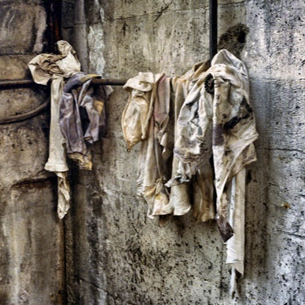  “But we are all as an unclean thing, and all our righteousnesses are as filthy rags; and we all do fade as a leaf; and our iniquities, like the wind, have taken us away.” ~ Isaiah 64:6  ____________________________________  If we want a correct diagnosis of humanity and ourselves, read the Bible. It will give us a correct diagnosis, and a correct diagnosis is necessary if a correct remedy is to be prescribed. Our verse gives us a correct diagnosis of man and the only remedy is Jesus Christ.  Forbidden. “Unclean.” This word in the Hebrew is used in a legal sense. This is illustrated by the laws of leprosy. If a leper was pronounced unclean, he was shut out of society. He was forbidden from many places because his leprosy would defile others. So it is with sinful man. He is forbidden entrance into heaven because his sin has made him unclean.  Filthy. “Filthy rags.” These two words describe what is enormously dirty. This is used to describe not only our sins, but also our righteousness. This tells us our very best we can do is worthless as far as our salvation is concerned. We cannot be saved by our works because they are filthy rags.  Fading. “We all do fade as a leaf. “This speaks of the work of sin upon us. Sin leaves a mark. How quickly life fades into eternity! The beauty of youth fades as our sin-filled bodies are overtaken because of the curse of sin. Like a garment that fades and will not hold its color, life dwindles away.  The remedy for all of this is Jesus Christ, he never fades nor fails. He has the power to give us eternal life free from sin.
This Week’s Questions – Issue # 128 – ISAIAH 61-66

What was Isaiah sent to bind? 61:1
What is the adjective used in 61:10 to describe the robe? Praise the Lord!

What is the land called in 62:4

We sing a song about this.

What are the redeemed of the Lord called in 62:12

What have men not heard or seen from the beginning of the world? 64:4

What is our righteousness called in 64:6?

What will God’s servant do in 65:14?

What will the wicked do because of God’s judgement? 65:14

What will God create? 65:17

What is God’s footstool? 66:1

_____________________________________________________________________________
YOUR NAME

