 | THE CALVARY EXAMINER Reading Plan and Quiz | Issue # 84
Even through God promised complete destruction of Israel if they didn’t repent. God promised “I will leave a _________ “ 6:8  Where would the remnant go and what would they do while in the mountains? V16  What would happen to those who cried for peace during the destruction? 7:25  What were the 25 men worshipping in the Lord’s house? 8:16  What was God’s response to their false worship? 8:18  Chapter 18 uses the term “Cherub” and Cherubim. What are they?  What went up from the Cherub and stood over the threshold of the house? 10:4  What appeared in the presence of the cherubim? 10:8  What is the name of the river mentioned throughout chapter 10? It’s mentioned many times in Ezekiel. It was likely a river that flowed into the Euphrates  No question but a point to make when studying Ezekiel.  When studying chapter 1, Compare notes to chapter 10. Wow, What a text!  Luke Last Week’s Answers – Issue # 83 | 09/29/24  THIS WEEK’S READING – Ezekiel 11-15  “LYING PREACHERS”  By Pastor Doug Swafford  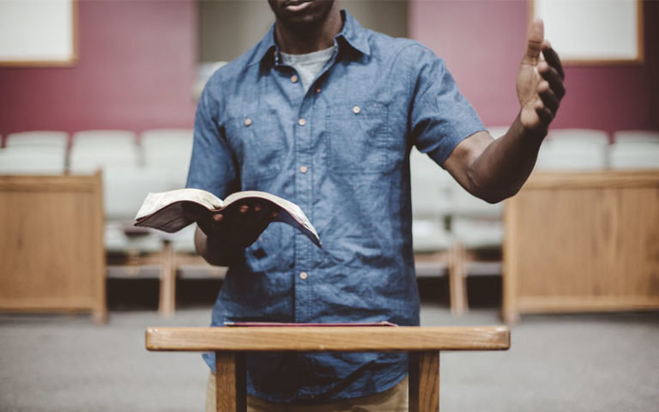  “Because with lies ye have made the heart of the righteous sad, whom I have not made sad; and strengthened the hands of the wicked, that he should not return from his wicked way, by promising him life.” ~ Ezekiel 13:22  _____________________________________  In this verse, God exposes the false prophets and their evil influence upon the people.  We see that the false prophets discourage the righteous. “Ye have made the heart of the righteous sad.” False ministers bring problems to the righteous and discourages their faith. Apostate preachers grieve righteous souls to sadness.  Next, we see they strengthened the hands of the wicked. False prophets encouraged the wicked. In our day many false ministers encourage unrighteousness and help evil. They claim to be Christians while supporting laws that favor evil behavior. They ordain wrongdoing and immoral conduct which only makes evil stronger.  The verse also tells us what happens when people have false ministers. “That he should not return from his wicked way.”  These false preachers were preventing the people from returning to righteousness. They seem to discourage repentance. What a sad statement about what happens when there is no righteous preaching!  Oh, that we would cry out to God. and seek preachers who will cry out against sin! We need it in the day we live, just as they did in Ezekiel’s day.
This Week’s Questions – Issue # 84 – Ezekiel 11-15

Who were the men who devised mischief and gave withed counsel? 11:1-2
What was Ezekiel told to tell these people? 11:4

The word “caldron” appears 3 times in chapter 11. What does this word mean?

Might need a concordance

Ezekiel asked God if He would destroy Israel altogether in 11:13. What was God’s response in 11:16-17?

An abbreviated answer is good.

What adjective does God use to describe the house of Israel? 12:9

As part of the judgement of God, where would he send many of the people of Israel? 12:13

God told Israel there would no longer be what two things in the house of Israel?

12:24

God told Ezekiel that Israel would deny that the prophecy would happen while they were alive in verse 12:22. What did God say in response? 12:23

“The days are….

Israel had false prophets. From where did they prophecy out of, instead of the Word of the Lord? 13:2-3

God described the prophets of Israel like what animal? 13:4

_____________________________________________________________________________
YOUR NAME

