 | THE CALVARY EXAMINER Reading Plan and Quiz | Issue # 68
Last Week’s Answers – Issue # 67 | 05/26/24  THIS WEEK’S READING – JEREMIAH 6-10
God told Jeremiah he knew him before what? Jer 1:5 Before I formed thee in the belly  What did Jeremiah use as an excuse to say he couldn’t speak? 1:6 for I am a child.  What did God tell Jeremiah not to be afraid of? 1:8 Be not afraid of their faces:  What two things did Jeremiah see in 1:11 & 13? - a rod of an almond tree. - a seething pot;  What did God tell Jeremiah to do in 2:2? Go and cry in the ears of Jerusalem  What are your thoughts regarding 3:5?  What promise was made to backsliding Israel if they would repent? 3:12 I will not cause mine anger to fall upon you: for I am merciful, saith the Lord, and I will not keep anger for ever.  What comparison is used of how Israel treated God? 3:20 as a wife treacherously departeth from her husband  What was one of the sins Israel was committing? 5:8 every one neighed (cried out) after his neighbor’s wife.  Israel’s sin caused what to be withholden? 5:25 good things | “NOT SAVED”  Pastor Doug Swafford  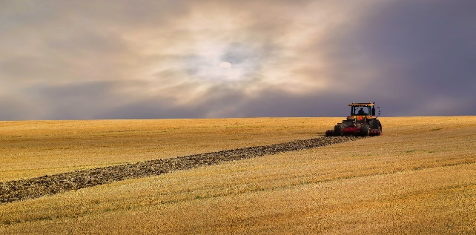  “The harvest is past, the summer is ended, and we are not saved.” ~ Jeremiah 8:20  _____________________________________  This verse is part of Jeremiah's reproof of Jerusalem. They were under siege by Babylon, and they kept thinking that deliverance would come soon. Harvest time and the summer had passed, yet they were not saved from Babylon.  This has an application to many souls regarding their spiritual need. They have come to an end of another year of their life, yet they're still not saved. The reasons they are not saved will often correspond to the reasons why Jerusalem was not saved.  One reason they were not saved was because they were not concerned. It was Jeremiah who was concerned, yet Jeremiah was protected by the king of Babylon, giving him freedom to go where he wanted. How true this is today regarding the souls of men. Often the lost are not concerned about their souls, but only those who are already saved are concerned about the lost. If the lost are not concerned about salvation, they will not get saved.  We also see a second reason they were not saved; it was because they would not confess their sin. In fact, they did not even blush over their evil according to Jeremiah 8:12. If the lost will not confess their sin, they will not be saved!  Harvest time and the summer are ending. Oh, that we who are saved would be concerned over the lost because time is running out!

This Week’s Questions – Issue # 68 – JEREMIAH 6-10

Who was given unto covetousness causing God to send Jeremiah unto Israel? 6:13
Was Israel ashamed of their sin?
What could they not even do regarding their sin? 6:15

Where did God tell Jeremiah to go to proclaim the Word? 7:2

What would they not harken to? 7:23-24

What 4 animals did God use as an example against Israel, since they did not know the time of judgement? 8:7

What are your thoughts concerning 8:22?

Why did Jeremiah want to go live in the wilderness? (He couldn’t because God had a job for him to do) 9:2

How did God establish the world? 10:12

Every man is _______ in his knowledge. 10:14 (It carries with it the idea of being dumb, dull-hearted)

What is not in a man to do? 10:23

_____________________________________________________________________________
YOUR NAME

