 | THE CALVARY EXAMINER Reading Plan and Quiz | Issue # 89
In Chapter 31 &32 God is giving Ezekiel a message to give to whom? Pharoah  What was the watchman to do when he saw the sword come? 33:3 Blow the trumpet  If the watchmen did not warn others, what would be required? 33:6 His Blood  Israel had a watchman. He was to do what for the Lord? 33:7 Hear the Word and Warn the people  What would happen to the wicked if they turned from their wickedness? 33:19 He shall live  Israel thought that since they inherited the land promised to Abraham that God would not destroy it. What was God’s response? 33:28 The land would become desolate  God speaks of himself as the great Shepherd of Israel in 34:11-19. After he destroyed them, he promised to make them a covenant of what? 34:25 Peace  The next prophecy of judgement was to whom? 35:2 Mount Seir  Why was God going to judge Seir? 35:5 Perpetual hatred for Israel  What would happen to the cities of Seir? 35:9 Destroy the cities  Luke Last Week’s Answers – Issue # 88 | 11/03/24  THIS WEEK’S READING – Ezekiel 36-42  “AFTER THE JUDGEMENT”  By Pastor Doug Swafford  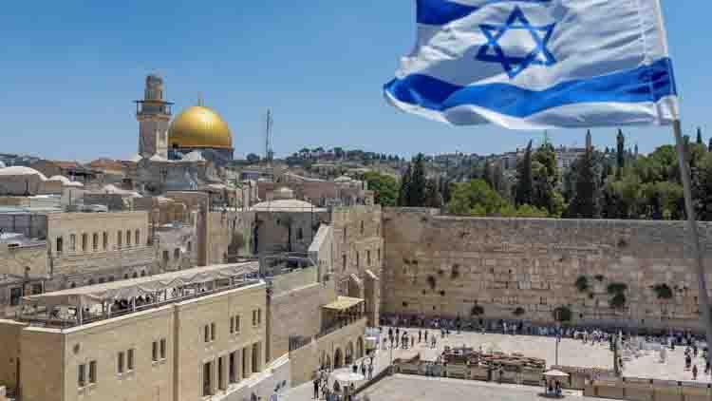  “And David my servant shall be king over them; and they all shall have one shepherd: they shall also walk in my judgments, and observe my statutes, and do them. And they shall dwell in the land that I have given unto Jacob my servant, wherein your fathers have dwelt; and they shall dwell therein, even they, and their children, and their children's children for ever: and my servant David shall be their prince for ever.~ Ezekiel 37:24-25  ____________________________________  As you read through Ezekiel, you find that Israel’s restoration is a prominent part in the later part of the book. The restoration is necessary for our verses to make sense.  The Old Testament is filled with promises of the restoration of Israel to great glory. Many nations are against Israel today, and the United Nations organization is certainly no friend of Israel. It matters not if Israel has friends among the nations of the world because God promises to be their friend. To the human eye, Israel's future may look bleak and uncertain, but to a student of scripture, no nation has such a glorious future.  In our verses we see that God gave David a covenant which said his throne would endure forever, and his seed would be on the throne. The term “David” does not mean him personally, but it is the figure used to describe the fulfillment of the promise that his seed will rule on the throne of Israel.  The seed that will fulfill this prophecy is none other than the Lord Jesus Christ. He is the King of kings and will come back to earth and set up his kingdom over Israel, and Israel will be the greatest nation on earth during the Millennium. This will happen when God draws them through the great tribulation.
This Week’s Questions – Issue # 89 – Ezekiel 36-42

In chapter 36 we see the beginning of the restoration of Israel. Verse 9 tells us God is with them and will do what two things so that they will produce fruit once again?
God would restore Israel for one reason, not because of their sake, but for what reason? 36:22

Chapter 37 is the chapter that describes Israel as dry bones. In verse 4 God tells the bones to do what?

Only God can make dry bones come to life

In verse 37:22 we see that Israel will no longer be divided as it was in Solomon’s day. How many kings would they now have?

In chapter 38:2 Ezekiel was told to prophecy against what two lands? We see them again in the Revelation

38:15 speaks of a great company and mighty army descending on Israel. What verse in Revelation 19 also speaks of this?

In verse 38:16 we see the prophecy outlined in Revelation as the nations will come against Israel in the later days. What is one way God will bring judgement to these nations? Revelation speaks of the blood up to the horse’s bridle!

What does 38:19 speak about happening in the land Israel? Revelation also speaks of this many times during the great tribulation.

In chapter 39:17, it speaks about birds gathering for a feast to eat the flesh. What verse(s) in Revelation speaks of the same?

Hint: Chapter 19

What will God do for the nation of Israel in 39:28?

_____________________________________________________________________________
YOUR NAME

