 | THE CALVARY EXAMINER Reading Plan and Quiz | Issue # 104
Where is a prophet usually without honor? 6:4 In his own country…  Why could Jesus not do mighty work in His own country? Because of their _____ 6:5-6 They still believed him to be a carpenter, a common man and not the Messiah Unbelief  Who went out and preached that men should repent? 6:12 The disciples  Who did Herod think Jesus was? 6:16 John the Baptist  Who did the damsel give the head of John the Baptist to? 6:28 Her mother  Why were the Pharisees unhappy with the disciples in Mark 7:2-5 Ate bread with unwashed hands.  What did the Pharisees seek from Jesus in 8:11? A sign  What was Jesus’ response to the Pharisees who sought for a sign? 8:12 It not about sight – but faith. They had enough signs to believe but still refused. There shall no sign be given unto this generation.  What did the disciples question? 9:9-10 “What the rising from the dead should mean”  What was easier than for a rich man to enter into the kingdom of God? 10:25 For a camel to go through the eye of a needle,  Last Issue’s Answers – Issue # 103 | 03/02/25  THIS WEEK’S READING – MARK 11-16  “NOBLE SERVICE”  By Pastor Doug Swafford  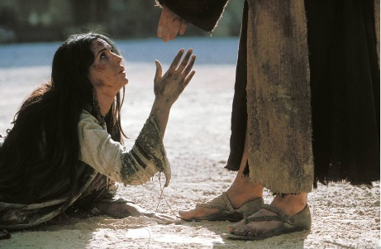  “She hath done what she could: she is come aforehand to anoint my body to the burying. ~ Mark 14:8  ____________________________________  Shortly before the crucifixion, Mary of Bethany, the sister of Martha and Lazarus anointed, Christ with some costly ointment in view of his coming death. This great deed was criticized by the disciples, but Jesus defended her.  We see her faith. “She is come aforehand to anoint my body to the burying.” Mary believed Jesus when he predicted that he would die. She showed her faith in Christ here by anointing him with this perfume for the burial. In those days people did not perform the embalming practices that we do today but wrap the dead body with some linen and covered it with various perfumes to ward off the odor of decay. So in anointing Christ with this perfume as she did Mary said by her conduct that she believed Christ would die. Her faith was not a popular faith for few believe this prediction by Christ about his death. Even the disciples did not believe Christ when he spoke of his death. But Mary believed and it's no wonder Christ commended her.  We also see her faithfulness. “She hath done what she could.”  God does not require us to do what we cannot do or what we have not been gifted to do. The only requires us to do what we are capable of doing. Our problem is that we do not do what we can do.  Are we using our talents and opportunities for the Lord? God is looking for a willing heart to do what we can.

This Week’s Questions – Issue # 104 – MARK 11-15

What did Jesus send two of his disciples to find? 11:1-2
Why did Jesus overthrow the tables of the moneychangers? 11:17

Why did the scribes and chief priest fear Jesus? 11:18

What are your thoughts about why Jesus cursed the fig tree? 11:13-14 & 20-22

No wrong answer

Why did the scribes and pharisees not answer Jesus about the baptism of John the Baptist? 11:29-33

What was a prominent doctrine of the Sadducees? 12:18

What question did the scribe ask Jesus? 12:28

After Jesus heard the scribe reply, what did he tell him? 12:34

He answered correctly but had no faith.

What Old Testament passage is Jesus quoting in 12:36

What would be a memorial of the woman who anointed Jesus? 14:9

Interesting thought! She was greatly honored.

_____________________________________________________________________________
YOUR NAME

