 | THE CALVARY EXAMINER Reading Plan and Quiz | Issue # 90
In chapter 36 we see the beginning of the restoration of Israel. Verse 9 tells us God is with them and will do what two things so that they will produce fruit once again? ye shall be tilled and sown:  God would restore Israel for one reason, not because of their sake, but for what reason? 36:22 but for mine holy name's sake,  Chapter 37 is the chapter that describes Israel as dry bones. In verse 4 God tells the bones to do what? Only God can make dry bones come to life hear the word of the Lord.  In verse 37:22 we see that Israel will no longer be divided as it was in Solomon’s day. How many kings would they now have? 1 king 1 kingdom  In chapter 38:2 Ezekiel was told to prophecy against what two lands? We see them again in the Revelation Gog, the land of Magog, the chief prince of Meshech and Tubal  38:15 speaks of a great company and mighty army descending on Israel. What verse in Revelation 19 also speaks of this? Verse 19 And I saw the beast, and the kings of the earth, and their armies, gathered together to make war against him that sat on the horse, and against his army.  In verse 38:16 we see the prophecy outlined in Revelation as the nations will come against Israel in the later days. What is one way God will bring judgement to these nations? Revelation speaks of the blood up to the horse’s bridle! God will bring them against the nation of Israel in order to judge them. Interesting thought how God will bring judgment by bringing them against Israel.  What does 38:19 speak about happening in the land Israel? Revelation also speaks of this many times during the great tribulation. Earthquakes! Many are mentioned in the Revelation. “in that day there shall be a great shaking in the land of Israel”  In chapter 39:17, it speaks about birds gathering for a feast to eat the flesh. What verse(s) in Revelation speaks of the same? Hint: Chapter 19 Revelation 19:17- “saying to all the fowls that fly in the midst of heaven, Come and gather yourselves together unto the supper of the great God;”  What will God do for the nation of Israel in 39:28? I have gathered them unto their own land,  Luke Last Week’s Answers – Issue # 89 | 11/10/24  THIS WEEK’S READING – Ezekiel 43-48  “THE FAITHFUL FEW”  By Pastor Doug Swafford  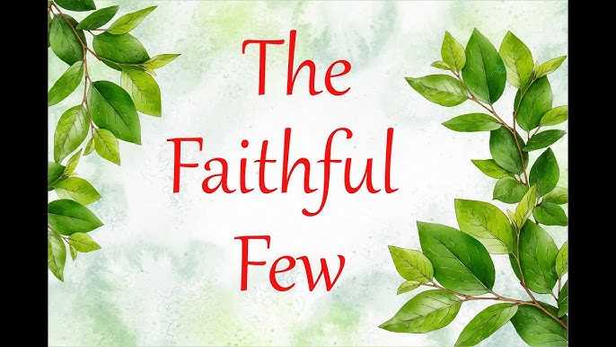  “It shall be for the priests that are sanctified of the sons of Zadok; which have kept my charge, which went not astray when the children of Israel went astray, as the Levites went astray.” ~ Ezekiel 48:11  ____________________________________  We have come to the final lesson in Ezekiel. So far, we have seen God’s judgement as Israel and others went astray.  In this verse we see something very encouraging. Amid all the sin and disappointments, we get a glimpse of a small group who remained faithful throughout all the wickedness. They are known as the sons of Zadok.  Our verse tells us they will receive a reward for their faithfulness. When everyone else in the land turned against God and disobeyed, these faithful few were true to God and now God recognizes them.  One might think that the Levitical priesthood whom God gave charge to perform the Tabernacle services would be the ones who would remain faithful. However, our verse clearly says even they went astray.  The sons of Zadok were like Noah and his family prior to the flood, and they found grace in the eyes of God.  It's not easy to do right when everyone else is doing wrong, but be faithful in every situation. God sees your faithfulness and will reward you in due time. God does not forget those who remain faithful through difficult situations. In the last chapter, God remembered the sons of Zadoc!

This Week’s Questions – Issue # 90 – Ezekiel 43-48

The Bible describes the voice of God in what way in 43:2? This same illustration is used many times throughout Scripture.
During the sacrifice for sin, they were to take the blood of the bullock and place it where? 43:20

Who was to perform the burnt offering sacrifice in Ezekiel 44:10? Even though they went away from God

What were the priest to teach the people? 44:23

What were the princes in Israel doing to the people prior to God’s judgement? 45:8-9

Who was to boil the sacrifices of the people? 46:24

How was the land divided?

47:21

The word “oblation” is mentioned about 35 times in the Scriptures. 48:9 is an example.

What does the word “oblation” mean?

Which group of people did not go astray when the children of Israel went did wrong?

48:11 – (Also mentioned in the devotional)

What is the name of the city? I believe much of the latter part of Ezekiel refers to the Millennial Reign and Temple.48:35

_____________________________________________________________________________
YOUR NAME

