 | THE CALVARY EXAMINER Reading Plan and Quiz | Issue # 67
Last Week’s Answers – Issue # 66 | 05/19/24  THIS WEEK’S READING – JEREMIAH 1-5
In 2 Corinthians 6:17 we are told to “come out from among them and be ye separate.” Who are “them?” Unbelievers – the world v14  There are two types of sorrow mentioned in 7:10. What are they? Godly sorrow & sorrow of the world - sorrow not toward Sin  After the first letter, the Corinthians repented of their sin. True repentance produced what 7 things? 7:11 Hint: “What ______” - Carefulness - Clearing - Indignation - Fear - Desire - Zeal - Revenge  Seeing that the Corinthian church repented, Paul said he rejoiced and had what? 7:16 I have confidence in you in all things.  What are your thoughts regarding 8:12?  Who was Paul’s partner and fellow-helper at this time in his ministry? 8:23 Titus  Who reaps sparingly? 9:6 He which soweth sparingly  11:13-15 warn of false apostles and deceitful workers. Why should we not marvel if we see these type ministers? V14 …for Satan himself is transformed into an angel of light.  How did Paul escape apprehension in Damascus? 11:33 …through a window in a basket was I let down by the wall  What are we encouraged to do in 13:5? Examine yourselves, whether ye be in the faith; prove your own selves. | “PLOWING AND PLANTING”  Pastor Doug Swafford  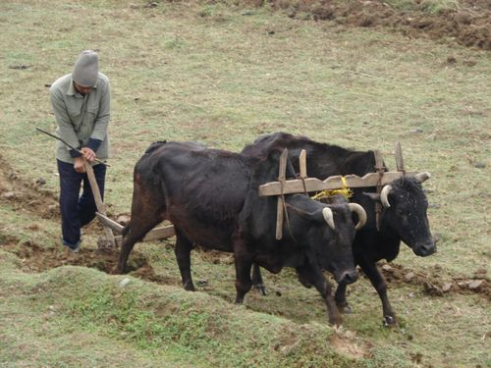  “For thus saith the Lord to the men of Judah and Jerusalem, Break up your fallow ground, and sow not among thorns.” ~ Jeremiah 4:3  _____________________________________  Jeremiah was a man called of God to preach repentance to a wicked and hardened people. This book contains Jeremiah’s message that the people needed to get right with God.  In our verse, he is exhorting them to repent, and he uses farmer's language of plowing and planting. We must “Break up our fallow ground” before we can plant seeds. An unplowed field can be very hard, and it makes it difficult, if not impossible, for the seed to grow spiritual fruit.  The heart needs to experience the plowshare of repentance if the good seed of the Word of God is going to be sown and bear fruit. Plowing the hard heart with confession of sin will be painful as the ploughshare rips open the soil of the hardened heart, but if there is no repentance, there is no revival.  He also tells us not to sow among the thorns. The farmer was to get rid of the thorns so they would not hinder the good seed from growing, and Christ tells us that these thorns are the cares, riches, and pleasures of the world (Luke 8). Its thorns take nutrients out of the soil that are needed for the good seed. The thorns of life drain away our energy and interest so that we have little left for spiritual growth. Remove the thorns by putting priorities on spiritual matters

This Week’s Questions – Issue # 67 – JEREMIAH 1-5

God told Jeremiah he knew him before what? Jer 1:5
What did Jeremiah use as an excuse to say he couldn’t speak? 1:6

What did God tell Jeremiah not to be afraid of? 1:8

What two things did Jeremiah see in 1:11 & 13?

What did God tell Jeremiah to do in 2:2?

What are your thoughts regarding 3:5?

What promise was made to backsliding Israel if they would repent? 3:12

What comparison is used of how Israel treated God? 3:20

What was one of the sins Israel was committing? 5:8

Israel’s sin caused what to be withholden? 5:25

_____________________________________________________________________________
YOUR NAME

