 | THE CALVARY EXAMINER Reading Plan and Quiz | Issue # 75
In chapter 36, God told Jeremiah to write in the “roll of a book” the things God told him. Who did Jeremiah get to help him write what he spoke? 36:4 Baruch the son of Neriah  Why did Jeremiah ask Baruch to go and read what was written in the roll? 36:5 the people in the Lord's house…and also thou shalt read them in the ears of all Judah…  What was the result in the people’s heart after hearing the reading of God’s Word? 36:16 they were afraid both one and other  Baruch was asked to go before king Jehoiakim and read the book. The King then asked Jehudi to bring the roll to him. What did Jehoiakim do with God’s Word? 36:23 ,..he cut it with the penknife, and cast it into the fire that was on the hearth  What did God tell Jeremiah to do after the roll was burned? 36:28 V32 says God added even more words. Take thee again another roll, and write in it all the former words that were in the first roll,  Jeremiah was put in prison again in chapter 37. Whose house was made into a prison? 37:15 Jonathan the scribe  Zedekiah brought Jeremiah out of prison in 37:17. What did he ask Jeremiah? Is there any word from the Lord?  What was the Word from the Lord to Zedekiah? 37:17 thou shalt be delivered into the hand of the king of Babylon.  Zedekiah’s response to the Word of the Lord is seen in 37:21. What did the king command them to do to Jeremiah? that they should commit Jeremiah into the court of the prison, and that they should give him daily a piece of bread  Nebuchadnezzar invaded Judah in chapter 39. What did the Babylonians do initially to Zedekiah? 39:7 The Story is retold in chapter 52 ..he put out Zedekiah's eyes, and bound him with chains, to carry him to Babylon.  Last Week’s Answers – Issue # 74 | 07/14/24  THIS WEEK’S READING – JEREMIAH 41-46  “DEVINE REVELATION”  Pastor Doug Swafford  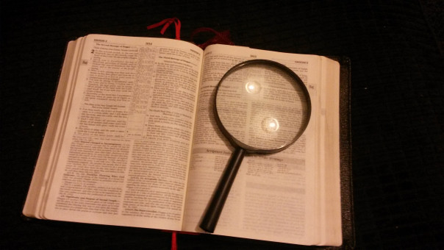  “And it came to pass after ten days, that the word of the Lord came unto Jeremiah.” ~ Jeremiah 42:7  _____________________________________  Things have gotten worse in Israel at the time of our verse. There had been an assassination of the appointed governor, Babylon was threatening to retaliate, many Jews wanted to flee to Egypt, and there was much betrayal among the people. A group of leaders came to the prophet Jeremiah and asked him to seek the Lord and tell them what they should do.  In our verse we see that Jeremiah went to the Lord for counsel, and we note two truths regarding this divine revelation.  Notice first, “When the divine revelation came. “After ten days.”  Jeremiah had to wait 10 days before God answered. This delay of 10 days reminds us that we do not learn everything all at once. Many times, we do not understand God’s revelation without patience. We do not comprehend the Bible in a short time of study. It can take many years of labor to develop our knowledge and understanding of the Word. Also, the waiting period tests our devotion and dedication. If we are not willing to wait on the Lord, we will not learn his revelations.  We also notice a second principle, “Where the divine revelation came.” The word of the Lord came to Jeremiah. God does not illuminate the minds of the disobedient. If we wish to understand God’s Word and truths, we must obey it! The disobedient children of Israel were blind from sin and needed Jeremiah to discover God's will. “If any man will do his will, he shall know of the doctrine…~ John 7:17.  Obedience is the key to divine revelations.
This Week’s Questions – Issue # 75 – JEREMIAH 41-46

Chapter 41 gives an account of a man by the name of Ishmael. How many men (soldiers) did he have with him? 41:2

Note: These men killed Gedaliah and all the Jews that were with him, the Chaldeans at Mizpah, the men of war there, and fourscore men from Shechem, from Shiloh, and from Samaria.

When God is against a nation he can bring them down with ease.
Where did Ishmael bury all the dead bodies? 41:9.

Later Ishmael met with an army too large to fight. How many men of Ishmael’s small army survived and went to the Ammonites? 41:15

Who asked Jeremiah to pray for them to know what they needed to do. 42:1

After Jeremiah prayed and waited 10 days for an answer. What was the answer and conditional promises that God made them, IF they obeyed? 42:10

What was the response of the people after hearing what God said? 43:2

As a result of their pride and refusal to repent, what did the people do? It was the opposite of what God told them. 43:7

What did God say he would do to the people because of their rebellion?

43:10-13 – (An abbreviated answer is good)

God sent judgment to those who fled to Egypt. Why were the valiant men swept away, and stood not? 46:15

What promise did God make the remnant of believers in Israel? 46:28b

_____________________________________________________________________________
YOUR NAME

