 | THE CALVARY EXAMINER Reading Plan and Quiz | Issue # 111
What did Abishai want to do to Saul when they found him asleep? 26:8 He wanted to kill him  Divid told Abishai not to kill him. What was the reason? 26:9 Because he was God’s anointed.  What two items did David and Abishai take from sleeping Saul? 26:12 The spear and the cruse of water from Saul's bolster;  Who was the king that helped David and his 600 men by giving them land to dwell in? 27:2-6 Achish  Why did Saul’s heart greatly tremble? 28:5 Because he saw the host of the Philistines  What happened when Saul enquired to the Lord? 28:6 God did not answer him  Who did Saul seek when he realized God would not answer him? 28:7 Never seek the spirits for answers! Horoscopes, fortune tellers, palm readers, Ouija boards, etc. are very wicked. God hates these things. Saul was about to find out how much God hated them. A woman that hath a familiar spirit,  Saul sought to hear from the dead. Who did he ask the woman to call up from the dead? 28:11 Samuel  What did Saul do to himself after he was wounded by the archers? 31:4 He fell on his sword  What happened to Saul’s body after he died? 31:12-13 It’s a sad ending for a man who made many wrong choices in life! He was burned and bones were buried under a tree  Last Issue’s Answers – Issue # 110 | 04/27/25  THIS WEEK’S READING – 2 SAMUEL 1-5  “GOD’S JUDGMENT”  By Pastor Doug Swafford  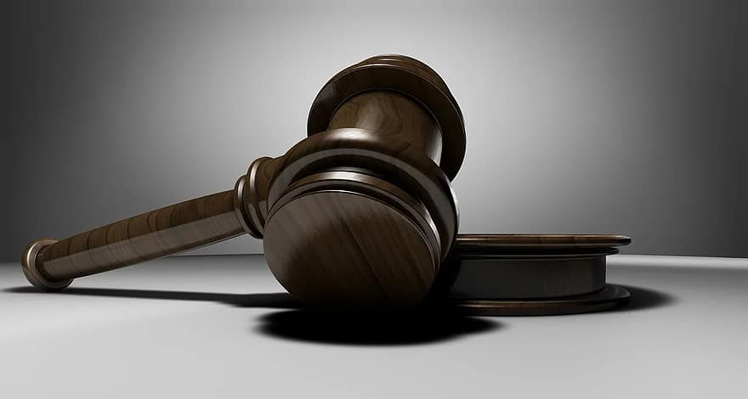  “And I am this day weak, though anointed king; and these men the sons of Zeruiah be too hard for me: the Lord shall reward the doer of evil according to his wickedness.” ~ 2 Samuel 3:39  ____________________________________  David's comments in our verse came after Abner was murdered by Joab. Abner killed Asahel (David’s nephew) and Joab with the help of Abishai took revenge and killed Abner.  This tangled act of murders and revenge was not pleasing to God.  In lamenting their evil, David said God would judge them according to their wickedness. From this verse, we note 2 important truths about God's divine judgement.  The Certainty of God’s Judgement. “The Lord shall reward the doer of evil.” This word “reward” does not mean reward in a good sense, but in a judgmental sense. David felt he was too weak to bring judgment upon Joab and Abishai because they were too strong. They were too strong politically and too strong with family ties for David to slay them. Although men are unable or unwilling to bring judgment on evil, God is not unable or unwilling. Criminals may beat human courts, but they'll never beat the divine court. God's judgment is certain upon all evil whether men punish it or not.  The Character of God's Judgment. “According to his wickedness.” God's court is just. There will be no plea bargaining or probated sentences. Judgement will be fair and rightful. Unless men come to Jesus Christ for salvation, they will be judged according to their wickedness.
This Week’s Questions – Issue # 111 – 2 Samuel 1-5

What did the young man who came from the camp of Saul tell David that he did to Saul?

1:10
Why did David kill the young man?
1:16

Who anointed David to be their new king? 2:7

Who wanted to make a league with David?

3:12-13

Who did David say died as a fool dieth?

3:33

Jonathan was a great friend to David. What was the name of Jonathan’s son?

4:4

How long did David reign as king?

5:4

Who wanted to kill David after hearing he was anointed king? 5:17

There is always opposition from Satan on God’s children. No rest for David!

After David slew some of the Philistines, what did he do with their images?

What did God use to tell David it was time to smite host of the Philistines? 5:24

_____________________________________________________________________________
YOUR NAME

