 | THE CALVARY EXAMINER Reading Plan and Quiz | Issue # 79
What example did Jesus use to illustrate that it was not unlawful to pluck and eat ears of corn? 6:1-4 David went into the house of God, and did take and eat the shewbread  Why were the Pharisees filled with madness? 6:6-11 Because Jesus healed on the Sabath  How long did Jesus pray in 6:12? He continued all night in prayer to God.  Why should we show mercy to others? 6:36 Because God the Father showed us mercy  Who is in danger of falling into a spiritual ditch? 6:39 The Blind who were being led by the blind.  We should never behold the mote that is in our brother’s eye if there is a beam in our own eye. What is a mote? 6:42 a dry stalk or twig, a straw; chaff  How can we determine if something/someone is good or corrupt? 6:43-44 a good tree bringeth not forth corrupt fruit; neither doth a corrupt tree bring forth good fruit. By their fruit  What are your thoughts regarding 6:46? This is optional Those who do not obey the Lord are not the Lords.  Who did Jesus marvel at? And why? 7:2-9 The Centurion - Because Jesus had not found so great faith, no, not in Israel.  Who was cumbered about and too busy to worship Jesus? 10:40 Martha  Last Week’s Answers – Issue # 78 | 08/18/24  THIS WEEK’S READING – LUKE 11-15  “PRODIGAL LIVING”  Pastor Doug Swafford  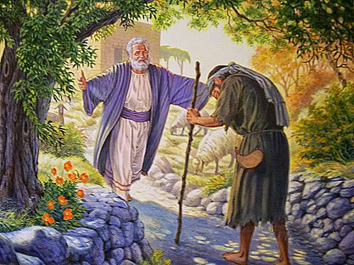  “And not many days after the younger son gathered all together, and took his journey into a far country, and there wasted his substance with riotous living.” ~ Luke 15:13  _____________________________________  The story of the prodigal son is repeated (except for the repentance part) in the lives of many of every age.  The Corruption of his fall. “...gathered all together.”  The prodigal gathered all his riches and quickly went to the swine. Riches, selfishness and greed corrupt quickly. The prodigal was selfish and greedy. He obtained riches as a result, but it all quickly led to his corruption.  The Country of his fall. “Took his journey into a far country.”  The word “far” is in reference to the prodigal’s father. The prodigal wanted to get far away from the restraining influences of his father and spiritually this speaks of the sinner getting far away from God. The far country represents the crowd that is far from God. When a person goes into sin, his crowd is not the godly crowd, but those who have little to do with the father.  The Conduct of his Fall. “…riotous living” the word “riotous” is translated from a word which literally means “un-saving.” It refers to a lifestyle that is undisciplined, loose, and devoid of character.  Praise God he didn't stay in the hog pen! He came to himself, repented and went to the father.

This Week’s Questions – Issue # 79 – LUKE 11-15

Why will the men of Nineveh rise in judgement against the people in Jesus’ generation? 11:21
Jesus told the Pharisees they ought to have tithed, but what did they leave undone? 11:42

What did Jesus compare the Pharisees to in 11:44?

What did Jesus call the leaven of the Pharisees? 12:1

What sin shall not be forgiven? 12:10

Why should we consider the Ravens?

12:24

Where will our heart be? 12:34

What are your thoughts regarding 13:23-24

This is optional

After reading 14:33, who cannot be Jesus’ disciple?

In the example of the prodigal son in 15:11-32, the son said he was not worthy of what? 15:21

Although we are not worthy, Praise God he still ran to us and kissed us in his mercy!

_____________________________________________________________________________
YOUR NAME

