 | THE CALVARY EXAMINER Reading Plan and Quiz | Issue # 160
Last week’s Answers  Numbers 26-30 | 05/31/26  THIS WEEK’S READING - NUMBERS 31-36  “CITES FOR REFUGE”  By Pastor Doug Swafford  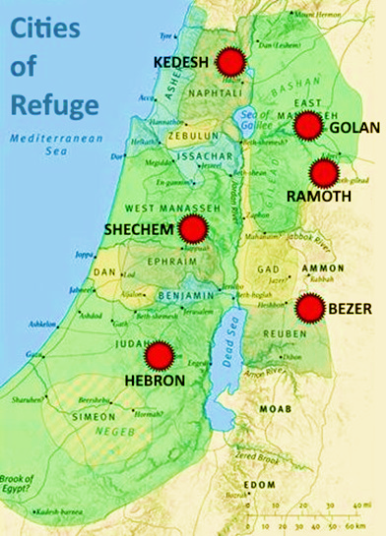  “And they shall be unto you cities for refuge from the avenger; that the manslayer die not, until he stand before the congregation in judgment.” ~ Numbers 35:12  ____________________________________  God ordered six cities to be set aside as cities for refuge. We will notice a few things about these cities of refuge.  Purpose of the cities. “For refuge from the avenger that the manslayer die not.” These cities provided protection from the avenger for the one who had unintentionally killed another person. The avenger, often blind with rage would kill the manslayer regardless of fault. The city of refuge would stop this unlawful revenge. It provided protection from a lawless society.  Places of the cities. We are told that six cities were set aside from among the cities where the Levites lived. Since the Levites lived throughout the land of Israel, this meant that the cities were located throughout the land. 3 were on the West side of Jordan, and 3 were on the east side of Jordan. They were easily accessed from any part of the land. There is a gospel lesson in their location. It tells us that the gospel, which is a refuge from judgment, is accessible to all. The gospel is for “whosoever” and is accessible for all men.  Proving in the cities. “Until he stand before the congregation in judgment.” The city of refuge was not to prevent justice. All those who fled to the cities eventually had to stand trial and prove their innocence. God is a God of justice. Christ died and paid the due judgment for our sin, so that God might forgive us and be just in doing so. Christ is our refuge!
  What did the Lord tell Moses to do regarding those 20 years and older? 26:1-2 | Take the sum of them
  Who did not die when the earth swallowed up Korah and his company? 26:11  They became leaders of music in the Tabernacle later. | The children of Korah
  How many siblings did Moses have? 26:59 | Two. Arron and Miriam
  After the people were numbered, what did God say would happen to them? 26:65 | They shall surely die in the wilderness
  If a man had no sons, who should his inheritance go to? 27:8 | His inheritance was to pass unto his daughter.
  Who did God tell Moses to lay his hand on to become the new leader of Israel? 27:18 | Joshua
  The burnt offering is described as being a  ______ ______ unto the Lord? 28:8 | Sweet Savor
  What was the requirement for the one kid goat to be a proper atonement? 28:30-31 | (they shall be unto you without blemish)
  How many offerings are mentioned for the Israelites to do in 29:39?  The number for “grace” in Scripture | 5 offerings
  What statutes of the law are listed in chapter 30? | Verse 16  Between a man and his wife, between the father and his daughter,
This Week’s Questions – Issue # 161 – Numbers 31-36

What group of people were the Israelites told to avenge themselves against? 31:2

What did Israel do to the ungodly castles of the Midianites? 31:10

Why was Moses wroth with his officers? 31:14-15

Why did the children of Reuben and Gad desire the land of Jazar? 32:1

Why was the Lord’s anger kindled? 32:10-13

How many cities were to be set aside for refuge? 35:6

What were the purpose of the refuge cities? 35:11

A person could not be put to death for what reason? 35:30

What were they to take no satisfaction for? 35:32

What could not happen with a tribes inheritance? 36:9

_____________________________________________________________________________
YOUR NAME

