 | THE CALVARY EXAMINER Reading Plan and Quiz | Issue # 172
Last week’s Answers  Joshua 16-20 | 08/23/26  THIS WEEK’S READING – JOSHUA 21-24  “THE BONES OF JOSEPH”  By Pastor Doug Swafford  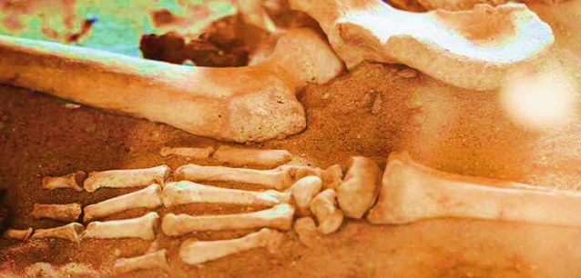  “And the bones of Joseph, which the children of Israel brought up out of Egypt, buried they in Shechem, in a parcel of ground which Jacob bought of the sons of Hamor the father of Shechem for an hundred pieces of silver: and it became the inheritance of the children of Joseph.” ~ Joshua 24:32  ____________________________________  The scriptures here mention the burying of Joseph's bones. Joseph had been dead for hundreds of years so why mention his bones now? The reason is that it gives a great lesson about faith.  Faith testifies. The Israelites brought the bones of Joseph with them because Joseph commanded them to do so in Genesis 50:24-25. When Joseph gave this order, he said that God would deliver Israel from Egypt. This statement was a statement of faith. Joseph believed the Word of God that promised Israel’s deliverance from Egypt, and he testified publicly of his belief.  Faith influences. When Israel left Egypt several centuries after Joseph's death, by faith Moses took the bones of Joseph with them in Exodus 13:19. Joseph's faith influenced Moses to the extent that Moses went to the trouble of taking the bones of Joseph when they left Egypt.  Faith honors. Our text tells us about Joseph’s bones being buried in Israel after Israel settled into the promised land. This burial was an honor for Joseph. After all these years, Joseph was honored for his faith. Faith always honors those who have faith. The greatest honor will be in heaven when God will highly honor the faith of others.
  Joshua 17:12-18.  When Manasseh complained they didn’t have enough land, what did Joshua tell them to do? | Cut down the wood and drive out the Canaanites.
  How many tribes had yet to receive an inheritance? 18:2 | Seven tribes
  Joshua sent 3 men from each of the 7 tribes to go and describe (survey) the land.  How was the land to be divided to the 7 tribes? 18:6 | Cast lots
  How did the men record the description of the land before they came back to Joshua? 18:9 | Describe it in 7 parts in a book
  What valley was “the valley of giants?”  18:16 | Valley of Hinnom
  Why did the tribe of Dan fight against Leshem? 19:47 | Because they had too little land
  What did the Lord tell Joshua to appoint in chapter 20? 20:2 | Cities of refuge
  What was the purpose of the cities of refuge? 20:3 | If someone accidentally killed another and needed to take refuge from an avenger
  Where was the fleeing person supposed to go first when they came to the refuge city? 20:4 | To the gate of the city and talk to the elders
  The jury system was ordained by God. Who was the accused to stand before for judgment? 20:6 & 9 | Before the congregation
This Week’s Questions – Issue # 172 – JOSHUA 21-24

In chapter 21, Israel finally possessed all the land and they were at peace. In verse 45, what never failed?

What would happen if Israel went back and cleaved unto the wicked nations again? 23:12-13

Joshua told the people that God provided them good things. What would God bring upon them if they turned against Him? 23:15

How did the Lord drive out the Amorites? 24:12

What did Joshua tell the people that he and his house will do? 24:15

After Joshua preached in 24:1-15, what was the people’s response? 24:16

What did Joshua tell the people they were witnesses against? 24:22

What did Joshua put under an oak tree to remind the people of their oath to serve the Lord? 24:26-27

How old was Joshua when he died? 24:29

Whose bones did the children of Israel bury in Shechem? 24:32

_____________________________________________________________________________
YOUR NAME

